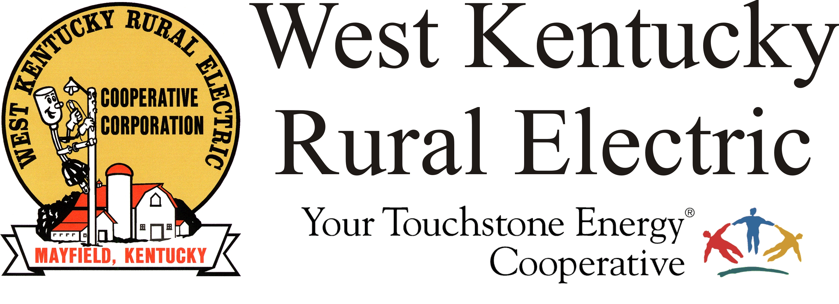

West Kentucky RECC Strom Damage Update

(Mayfield, Ky.) Dec. 11, 2021 (9:30 a.m.) – Daylight reveals the enormous damage left behind by last night’s severe weather. Our area experienced a direct hit from one of the largest, most powerful tornadoes ever to strike our region, as well as multiple other storm cells with damaging straight-line winds. About three-quarters of WKRECC’s 38,000 meters are without power at this time.

We are thankful to report that our team members are safe, and while some have experienced substantial damage to their homes and property, they are here, dedicated to restoring power to our members. Keep them in your prayers.

In addition to the damage to our distribution system, our power provider, TVA also has damage to the lines and towers that deliver power to our substations, Right now we have three substations with full power and one with partial power; nine more stations are completely without power.

TVA is assessing the damage and deploying resources to make repairs. As power returns to the substations, we will see overall number of outage drop.

Meanwhile we have all available resources in the field making repairs and we will be working around the clock until power is restored. We have requested mutual aid from other cooperatives and the first of those visiting crews has arrived. We expect to be joined by many more later today and tomorrow. Our three business offices will be closed on Monday, Dec. 13. The night drop boxes are available for payments.

Please continue to stay away from downed power lines.

We want to emphasize that this is going to be a lengthy repair process. While some members may be restored within 24 hours, other may face several days without power. Anyone with electricity-dependent medical devices or other health concerns should arrange for an alternate power source. Please take steps to make sure your family is safe.

WKRECC’s outage map continues to be out of service due to a damaged fiber optic line.

Phone service has been restored to our dispatch center, but the region is experiencing widespread phone and cell outages and many members report they are unable to get through.

Our primary communication method will be here on Facebook, with updates taking place approximately every four hours.

We are cooperating with local officials, law enforcement, the Kentucky Dept of Highways and other organizations.

Find helpful facts about power outages on our website at www.wkrecc.com.

